Statue of 'racist' Gandhi removed from Ghana university campus
SOURCE: AL JAZEERA AND NEWS AGENCIES
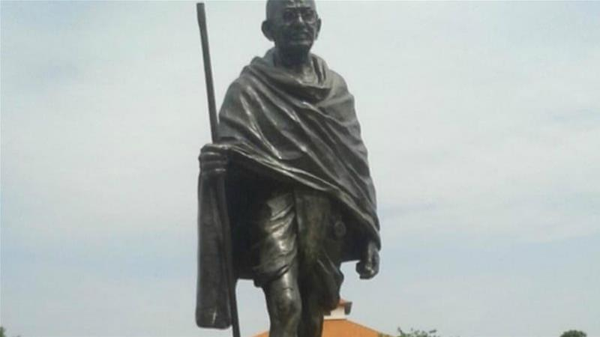
A statue of Indian independence leader Mahatma Gandhi has been removed from Ghana's most prestigious university following complaints that he was racist against the black Africans.
The statue, installed at the University of Ghana in capital Accra, was removed in the middle of the night earlier this week after protests from students and faculty.
India's former president Pranab Mukherjee had unveiled the statue two years ago as a symbol of ties between the two nations.
READ MORE

Ghana: Call to remove Gandhi statue over 'racist views'
But professors at the university soon began a petition calling for its removal. They cited passages written by Gandhi depicting Indians as "infinitely superior" to black Africans and using the racist pejorative "kaffirs" to describe them.
One of Gandhi's writings cited in the petition read: "Ours is one continual struggle against a degradation sought to be inflicted upon us by the Europeans, who desire to degrade us to the level of the raw Kaffir whose occupation is hunting, and whose sole ambition is to collect a certain number of cattle to buy a wife with and, then, pass his life in indolence and nakedness."
The online protest was one of a number on university campuses in Africa and beyond about the enduring symbols of the continent's colonial past.

'Victory for black dignity'
The Gandhi statue on the university's Legon campus in Accra appeared to have been removed overnight on Tuesday, students and lecturers told AFP news agency.
The head of language, literature and drama at the Institute of African Studies, Obadele Kambon, said the removal was an issue of "self-respect".
"If we show that we have no respect for ourselves and look down on our own heroes and praise others who had no respect for us, then there is an issue," he said.
READ MORE

Gandhi: 125 years since whites-only train incident
"If we indeed don't show any self-respect for our heroes, how can the world respect us? This is a victory for black dignity and self-respect. The campaign has paid off."
Adelaide Twum, a student, said the move was "long overdue".
"I'm so excited. This has nothing to do with diplomatic ties," she added.
Another student, Benjamin Mensah, said, "It's a massive win for all Ghanaians because it was constantly reminding us of how inferior we are."
The university authorities refused to comment. An official at Ghana's foreign affairs ministry said it was "an internal decision by the university".
Ghana's former government had said the statue would be relocated "to avoid the controversy ... becoming a distraction from our strong ties of friendship" with India.
Campaigners in Malawi are currently trying to stop a statue of Gandhi going up in the capital, Blantyre, arguing that he used racial slurs against black people.
Though Gandhi is more commonly remembered for his non-violent resistance to British colonial rule in his native India, his legacy in Africa is mixed.
Born in 1869, Gandhi lived and worked as a lawyer in South Africa from 1893 to 1915 before he left for India to continue his anti-colonialism struggle.

